1. Linked List Cycle

Given a linked list, determine if it has a cycle in it.

To represent a cycle in the given linked list, we use an integer pos which represents the position (0-indexed) in the linked list where tail connects to. If pos is -1, then there is no cycle in the linked list.

**Example 1:**

Input: head = [3,2,0,-4], pos = 1  
Output: true  
Explanation: There is a cycle in the linked list, where tail connects to the second node.

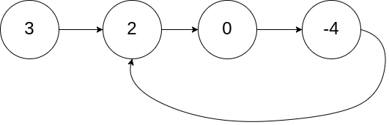

img

**Example 2:**

Input: head = [1,2], pos = 0  
Output: true  
Explanation: There is a cycle in the linked list, where tail connects to the first node.

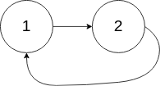

img

**Example 3:**

Input: head = [1], pos = -1  
Output: false  
Explanation: There is no cycle in the linked list.



img

**解法1** hashset

/**  
 * Definition for singly-linked list.  
 * struct ListNode {  
 * int val;  
 * ListNode *next;  
 * ListNode(int x) : val(x), next(NULL) {}  
 * };  
 */  
class Solution {  
public:  
 bool hasCycle(ListNode *head) {  
 unordered_map<ListNode*, bool>vis;  
 ListNode* p = head;  
 while(p){  
 if(!vis[p]){  
 vis[p] = true;  
 }else{  
 return true;  
 }  
 p = p->next;  
 }  
 return false;  
 }  
};

**解法2** 双指针

class Solution {  
public:  
 bool hasCycle(ListNode *head) {  
 unordered_map<ListNode*, bool>vis;  
 if(head == NULL || head->next == NULL)return false;  
 ListNode* p = head, *pp = head->next;  
 while(p != pp){  
 if(p == NULL || pp == NULL || pp->next == NULL)return false;  
 p = p->next;  
 pp = pp->next->next;  
 }  
 return true;  
 }  
};